NAAN MUDHALVAN

SALESFORCE PROJECT REPORT

COLLEGE: **SCAD COLLEGE OF ENGINEERING AND TECHNOLOGY**

TITTLE: **Application to Make The Gas filling station Easy using CRM**

BATCH-10

|  |  |  |
| --- | --- | --- |
| **NAME** | **NM ID** | **REG NO** |
| ADAM MOHIDEEN SAA | 17BEE4A3382D9BE879B4DDE536C9E428 | 952820114304 |
| HASAN MOHAMED A | 5D89AEDBF34320F81714BC38B090C117 | 952820114315 |
| IGMATH MALUKKAMALI A | 8E4B7811F4E7B96B11F4919BF5BAD93C | 952820114316 |
| JAINULABDEEN TA | F0ED4E5C874C91AA9344B4BDC5E4B10E | 952820114318 |

Step 1: Create a Salesforce Account

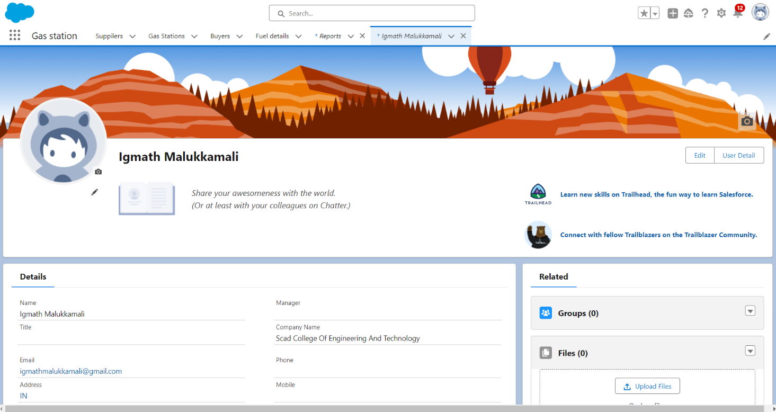

Step 2 : Create the Objects( SUPPLIER,GAS STATION,BUYER,FUEL DETAILS)

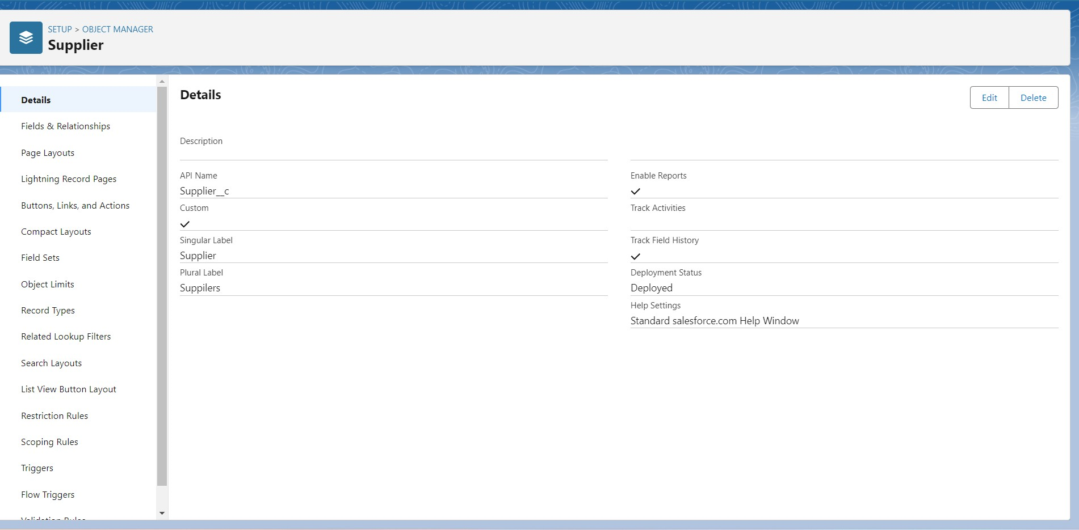

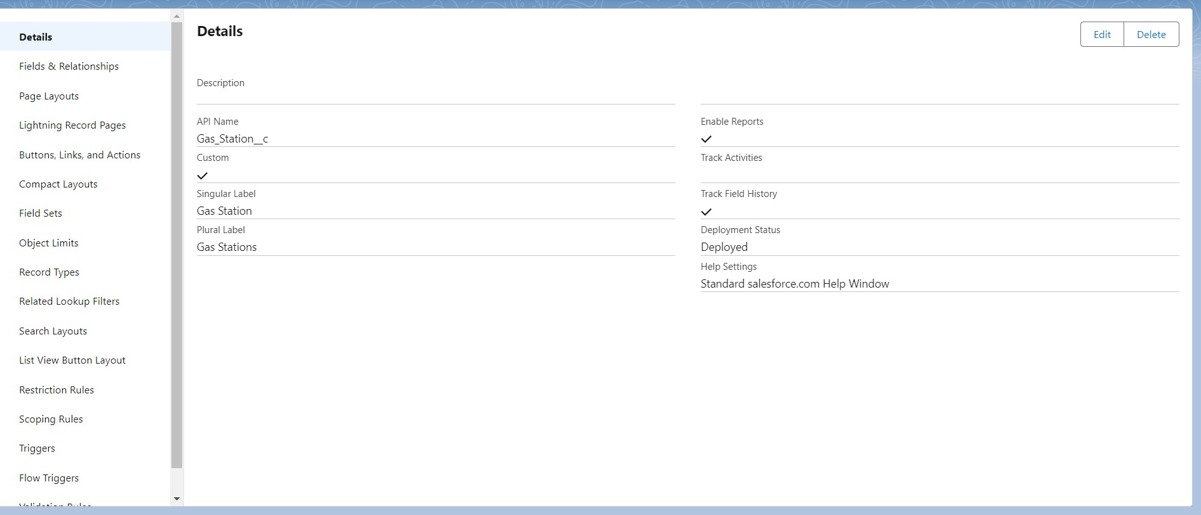

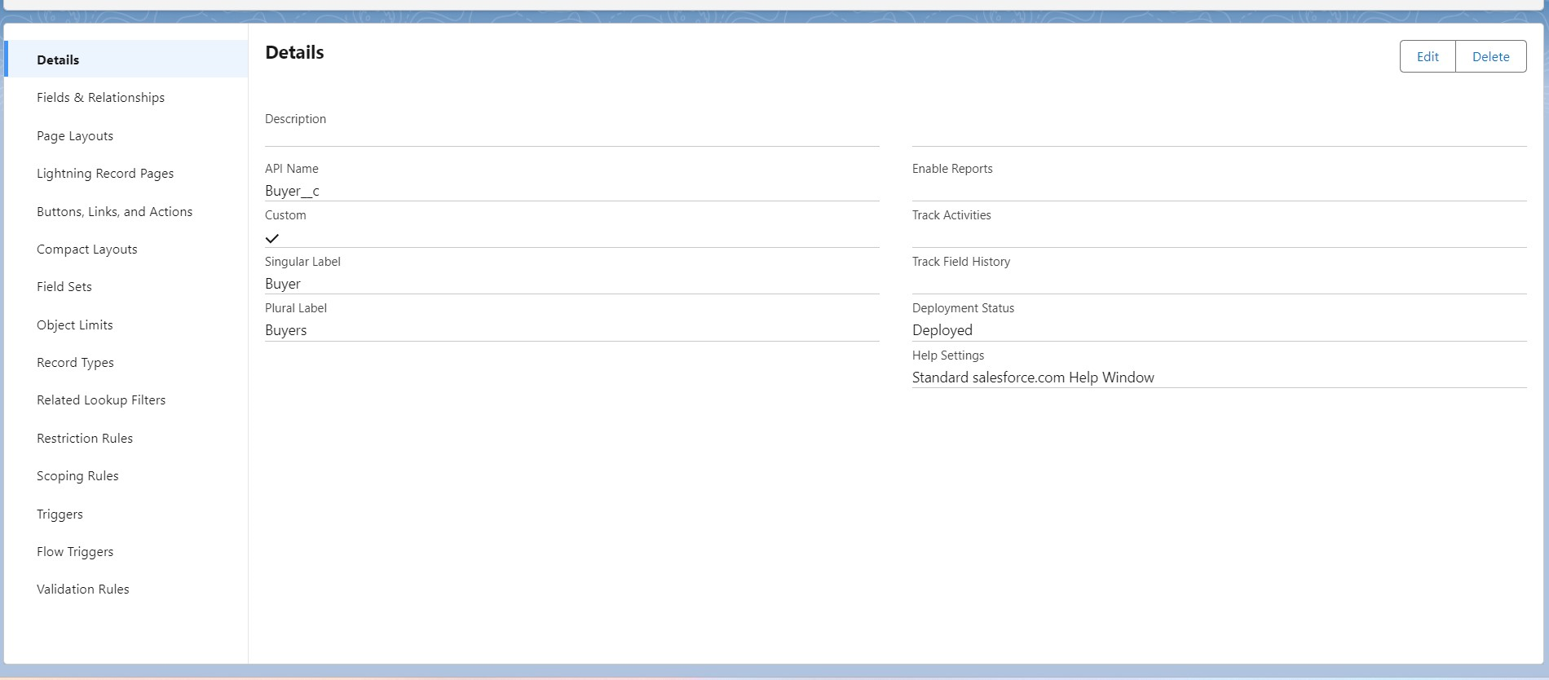

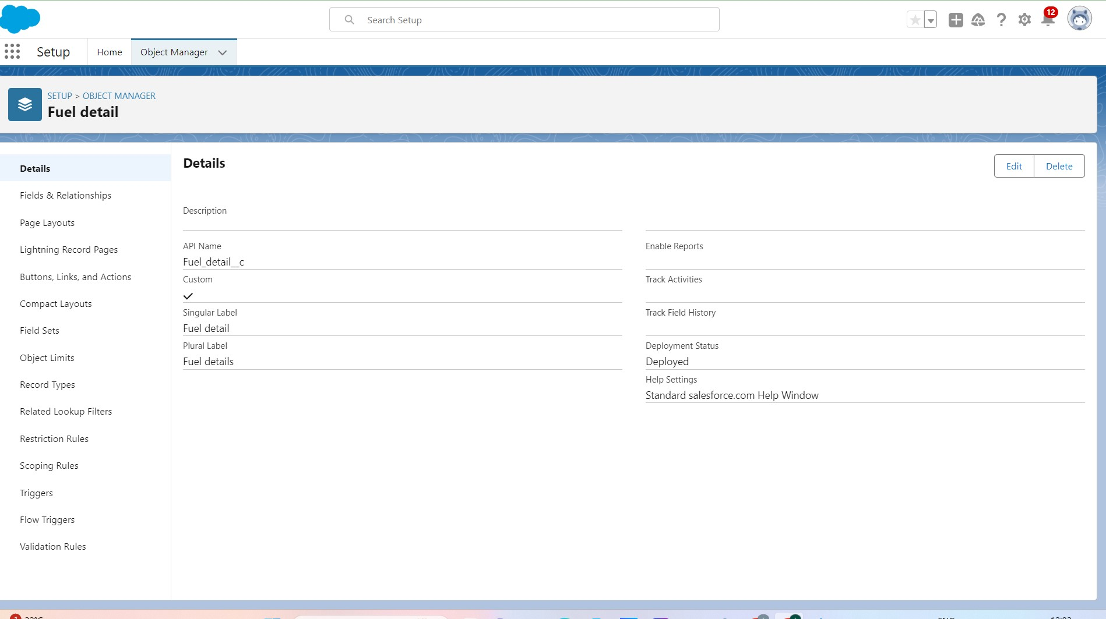

Step 3 : Create Custom Tab objects(SUPPLIER,GAS STATION,BUYER)

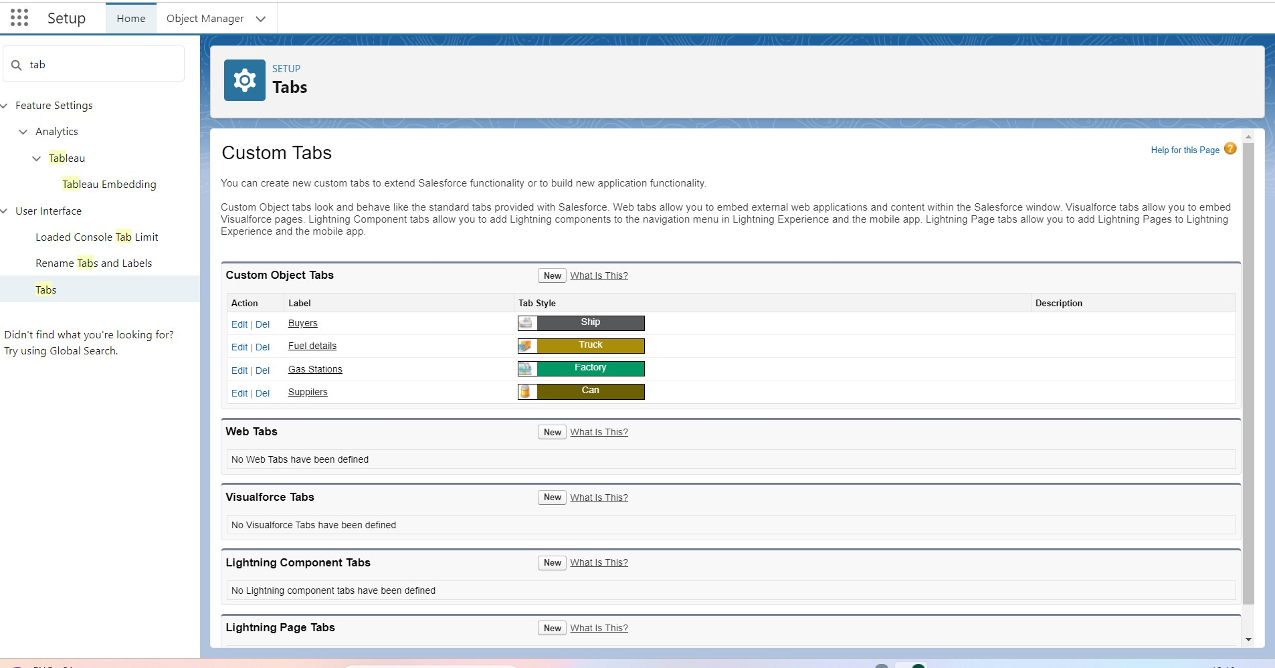

Step 4 : Create Field&Relationship object(School, student, Parent)

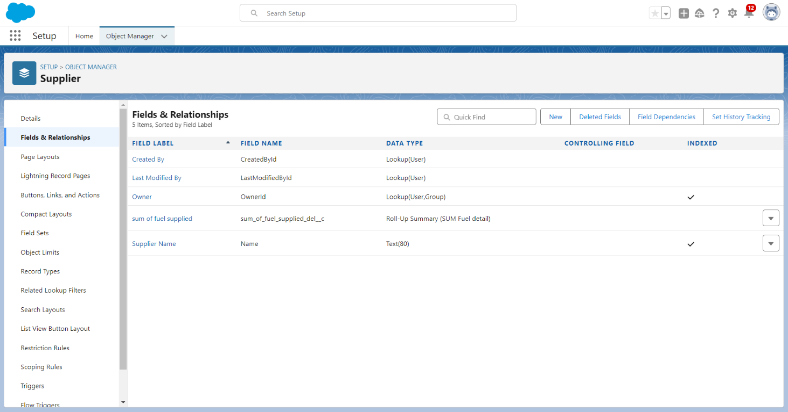

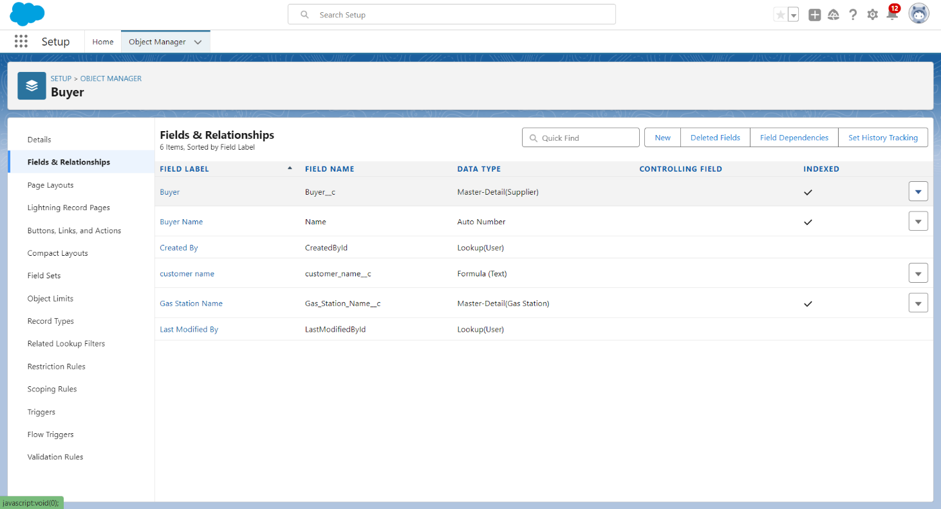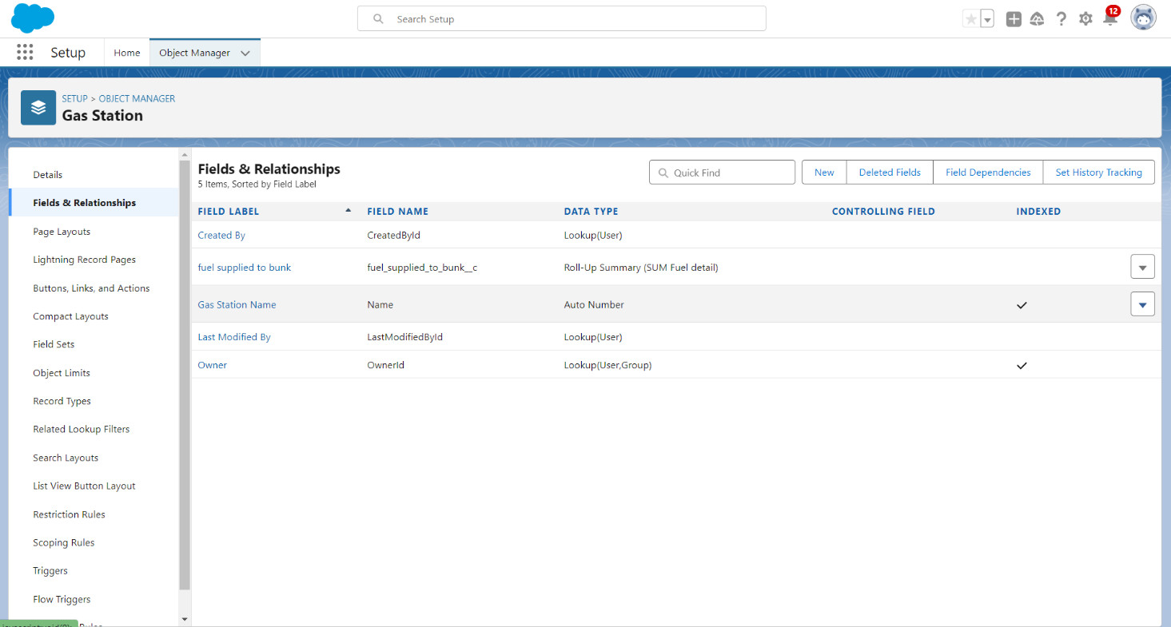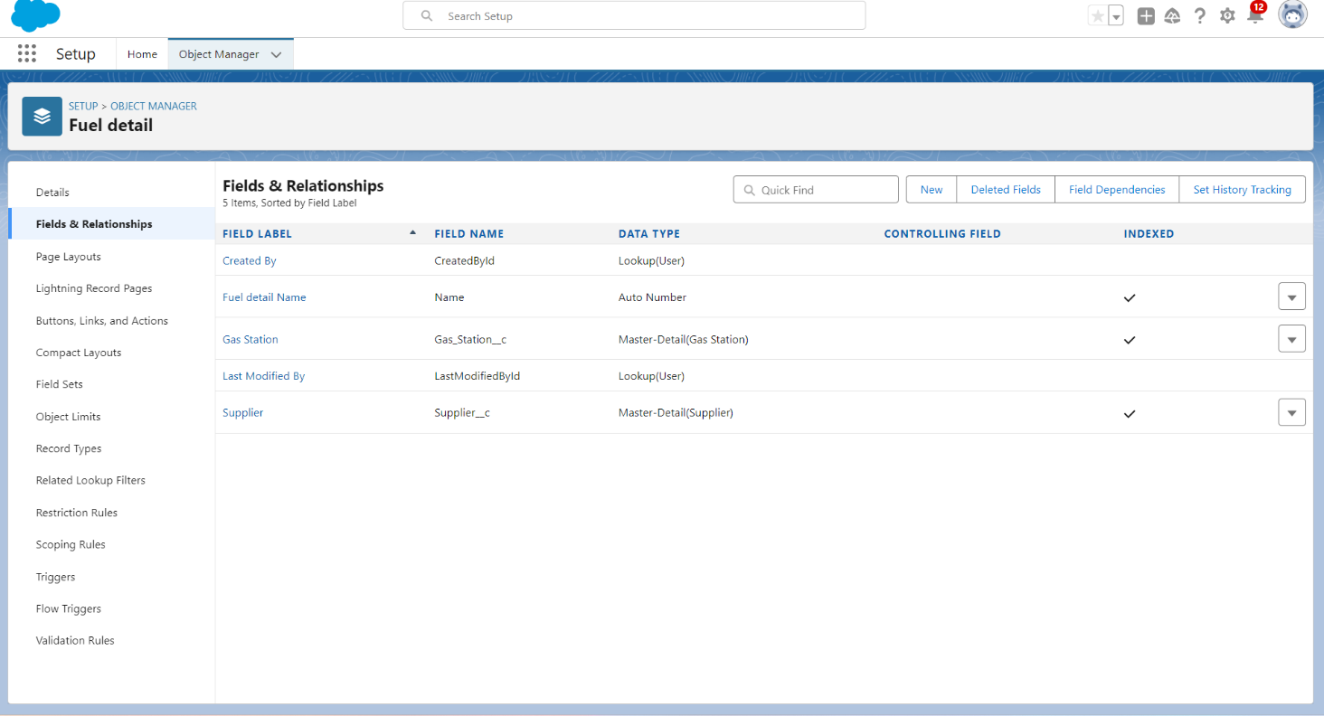

Step 5 : Create a Page Layout(SUPPLIER,GAS STATION,BUYER,FUEL DETAILS)

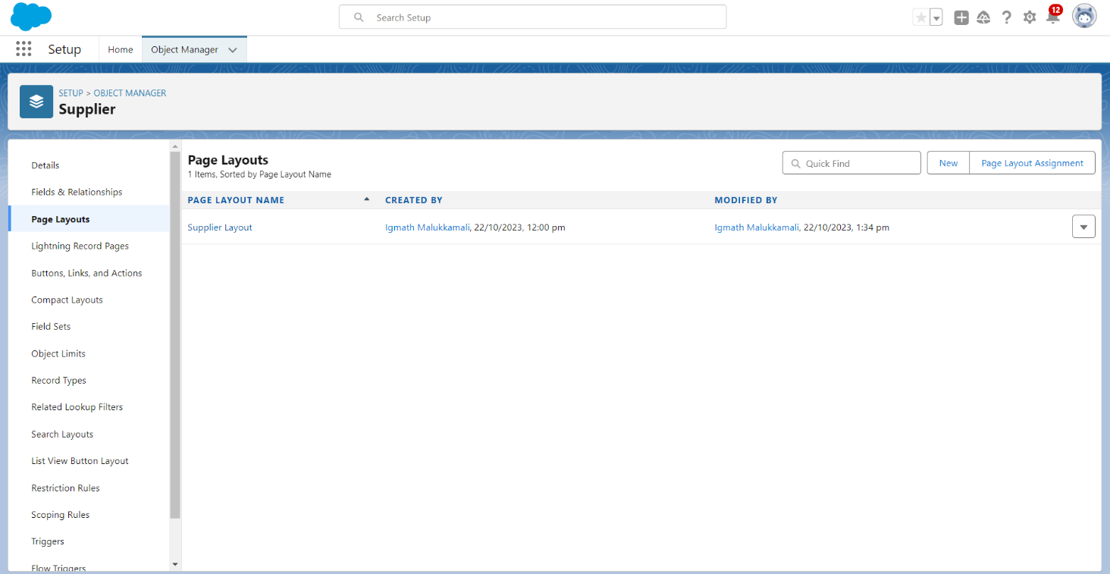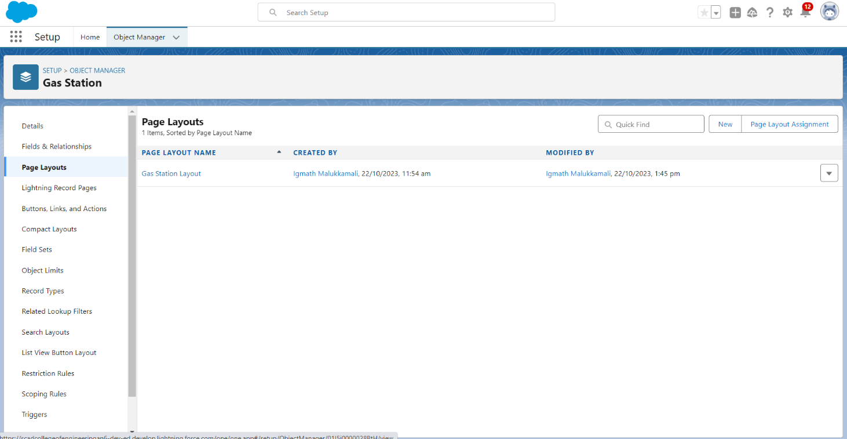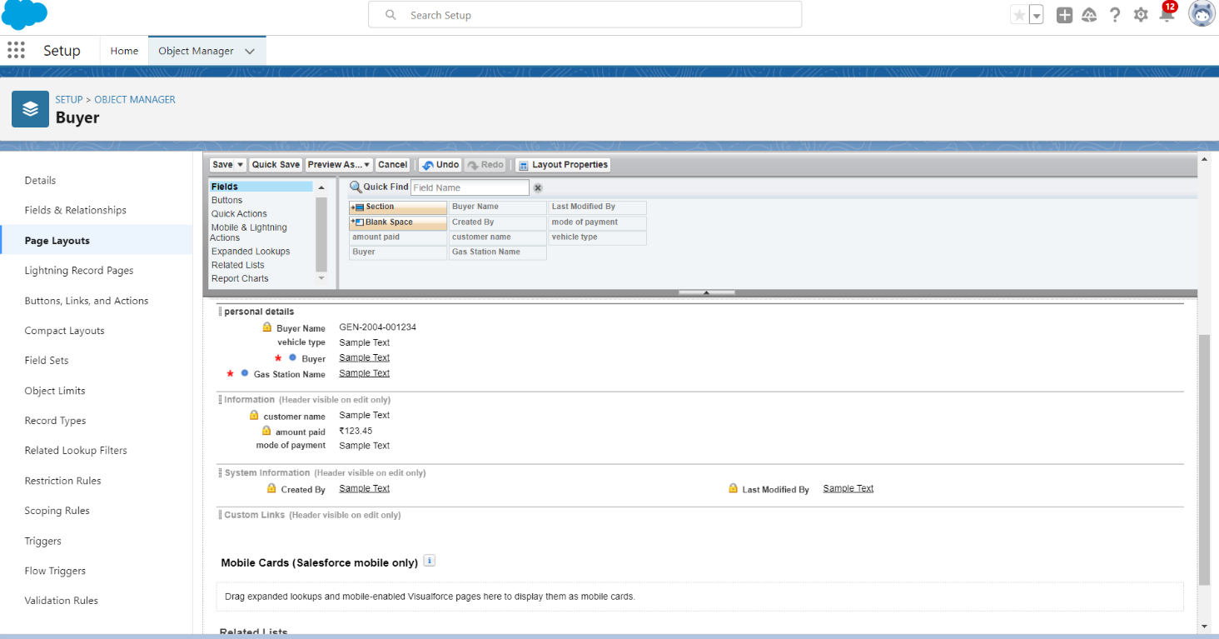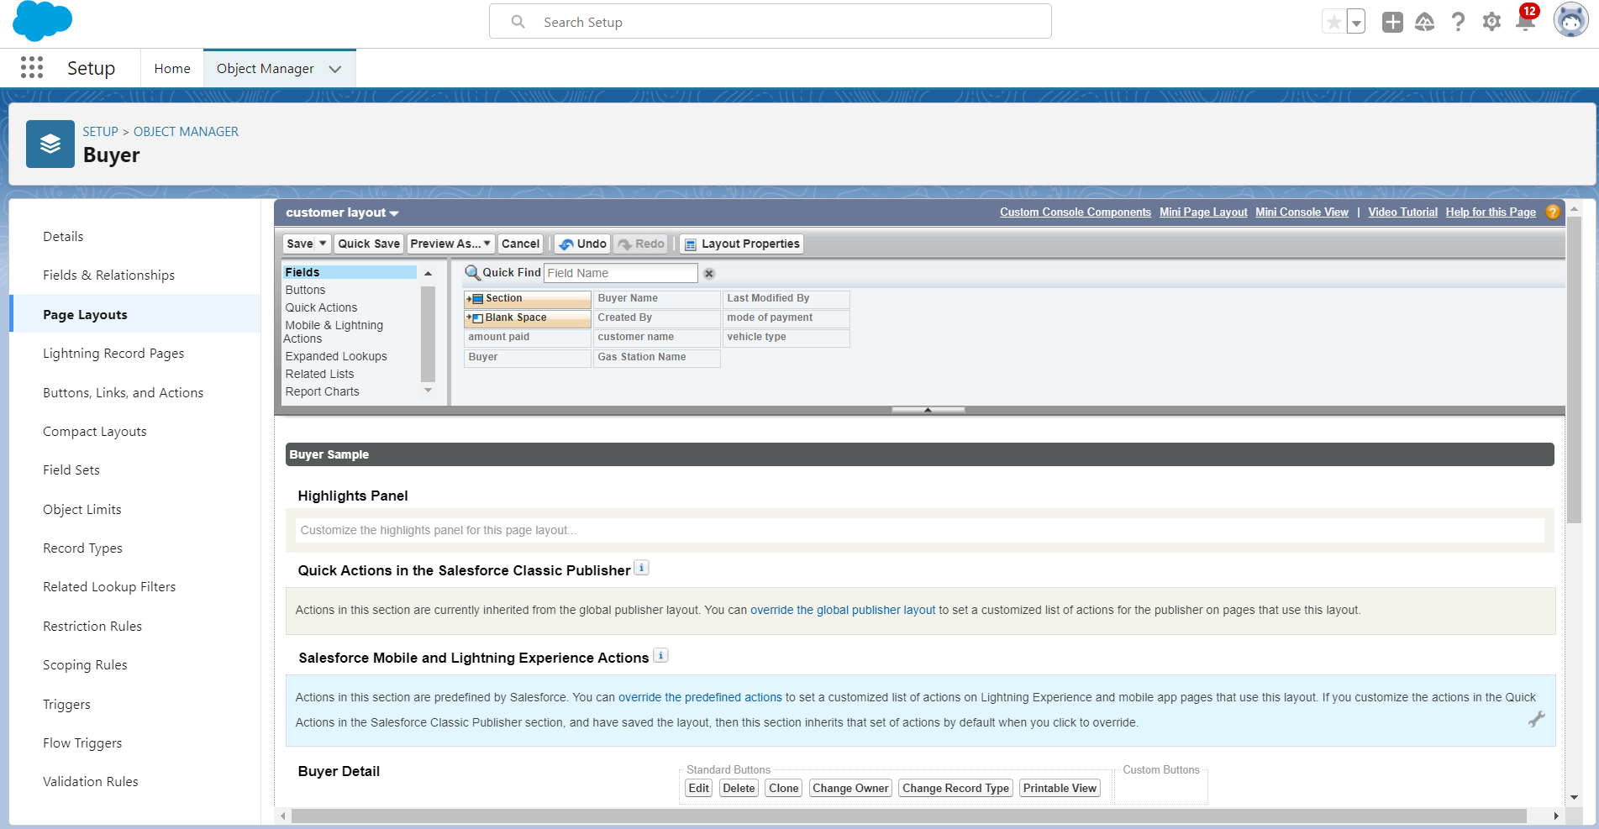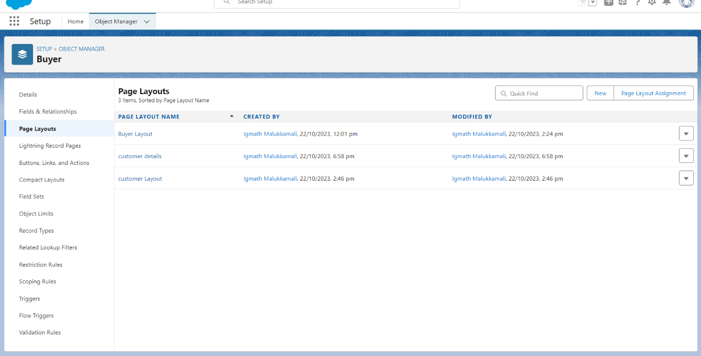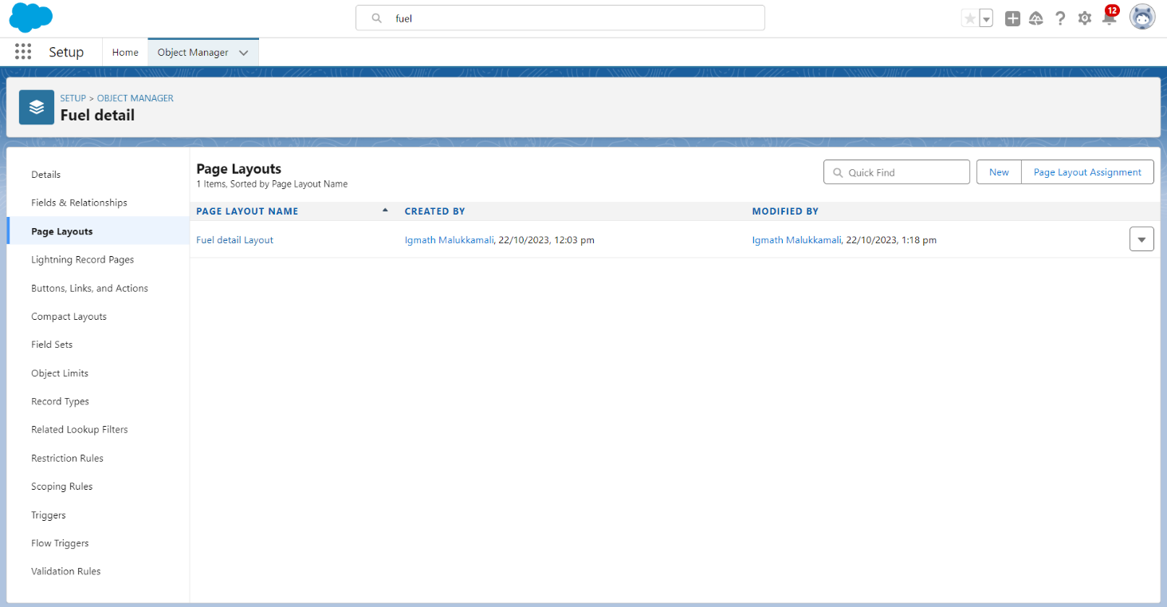

Step 6 : Create the Sales Profile

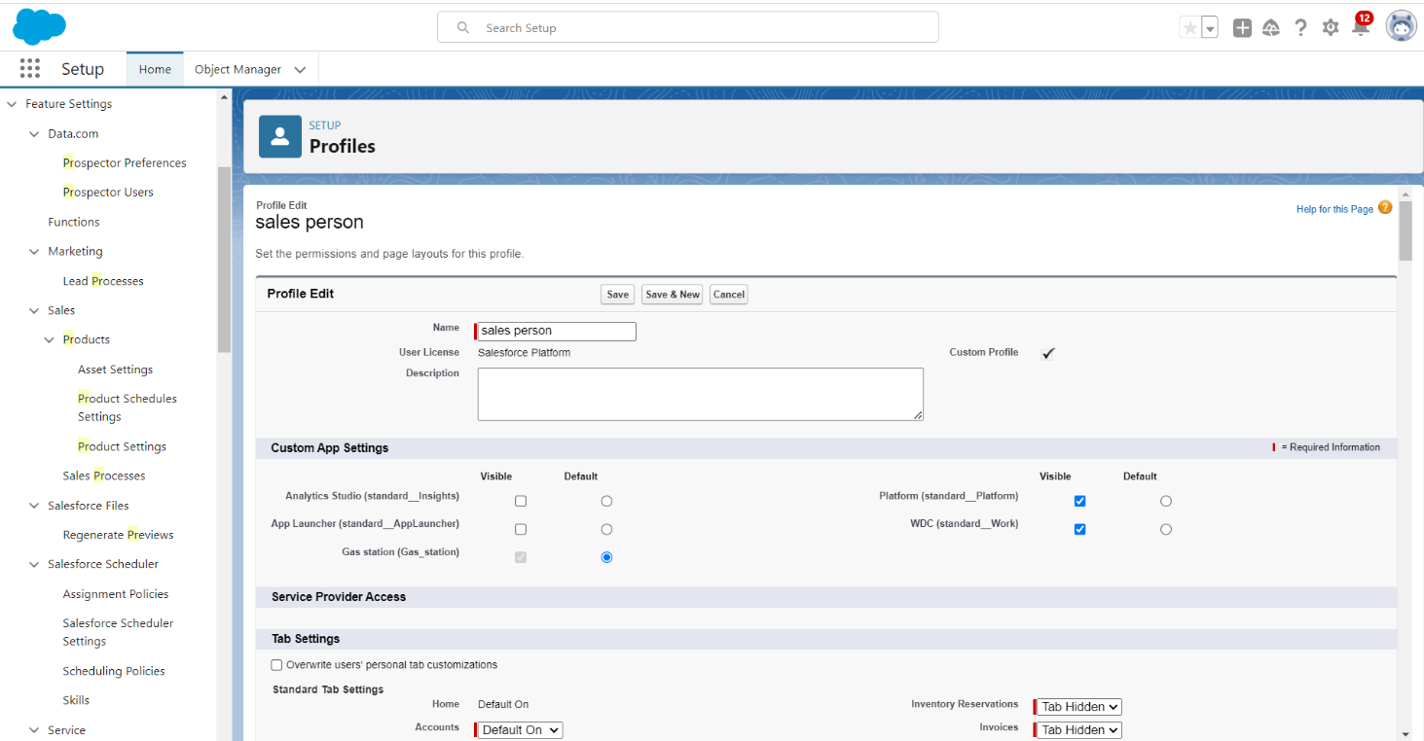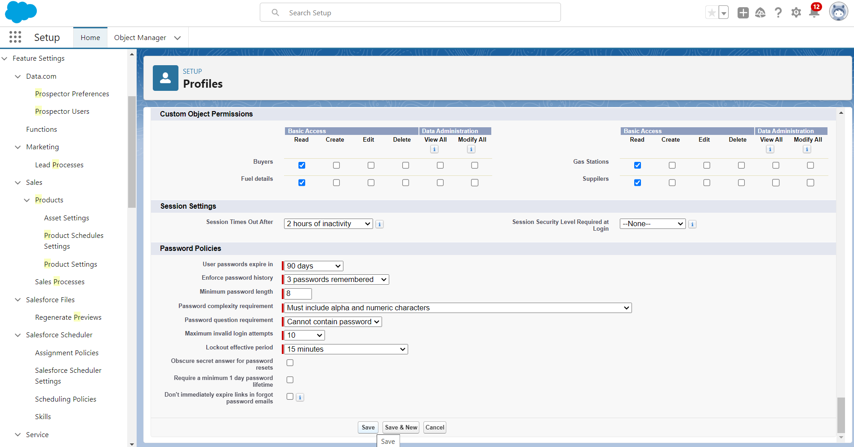

Step 7 : Create The Roles

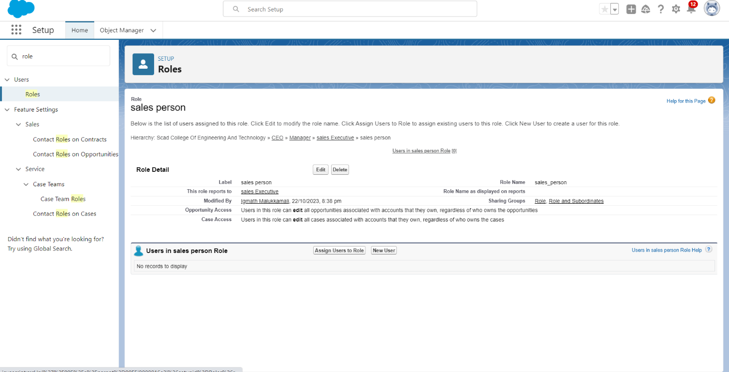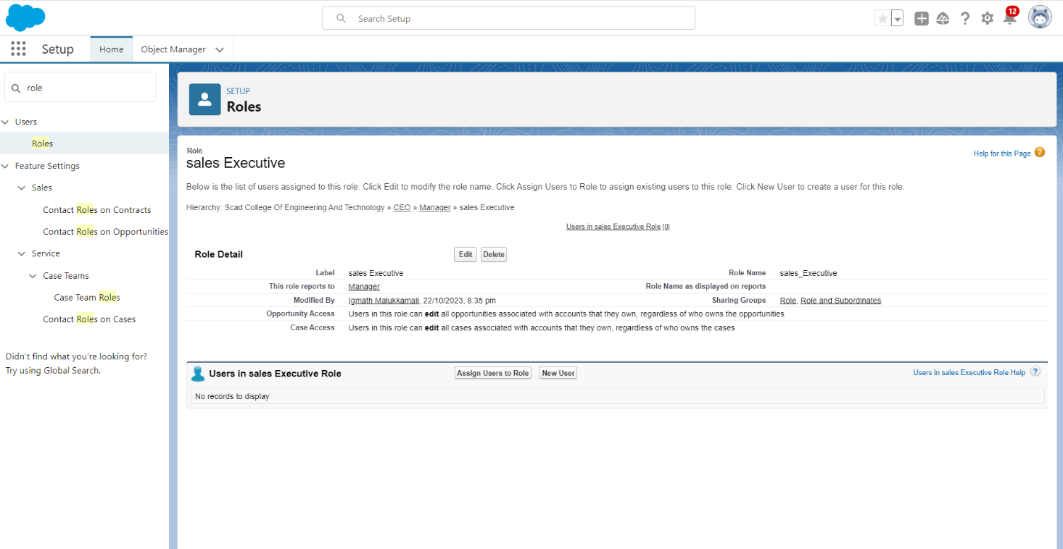

Step 8 : Create the Permission Set for the User’s

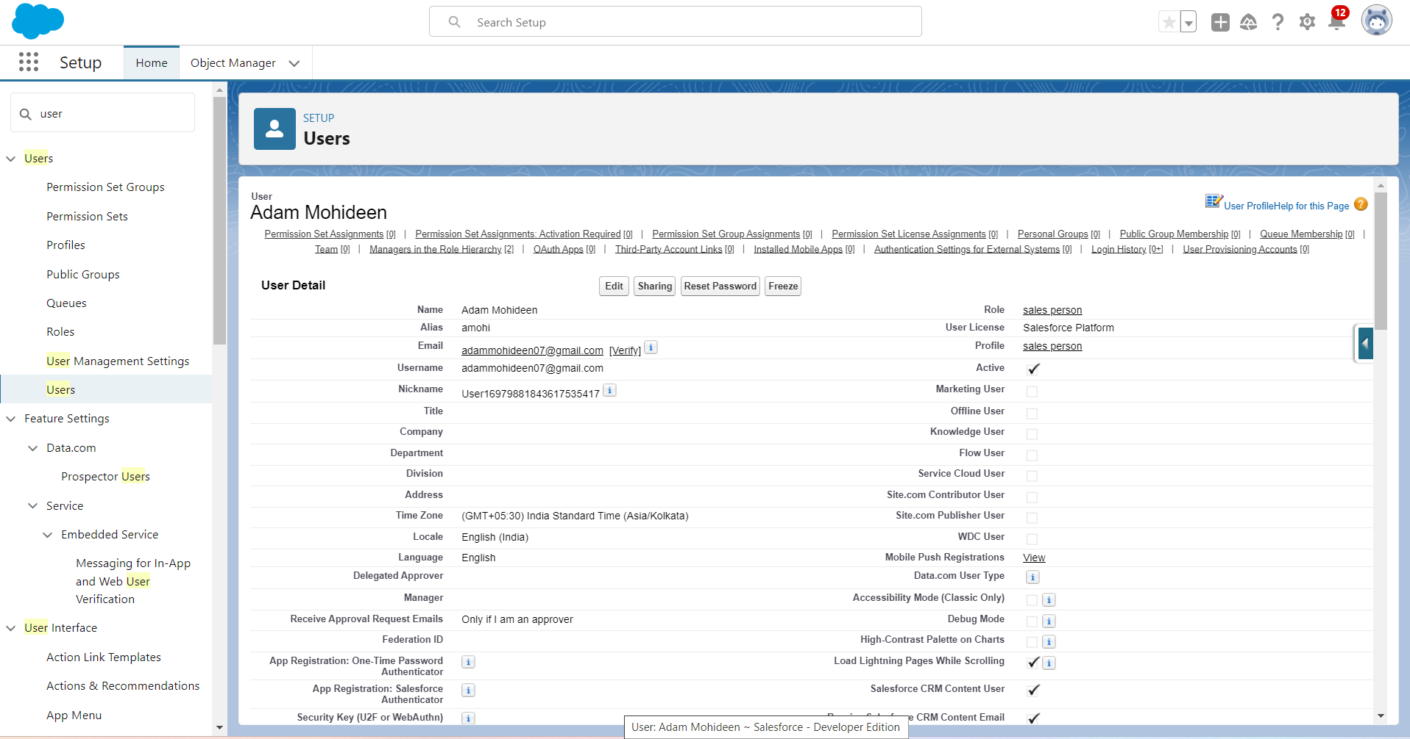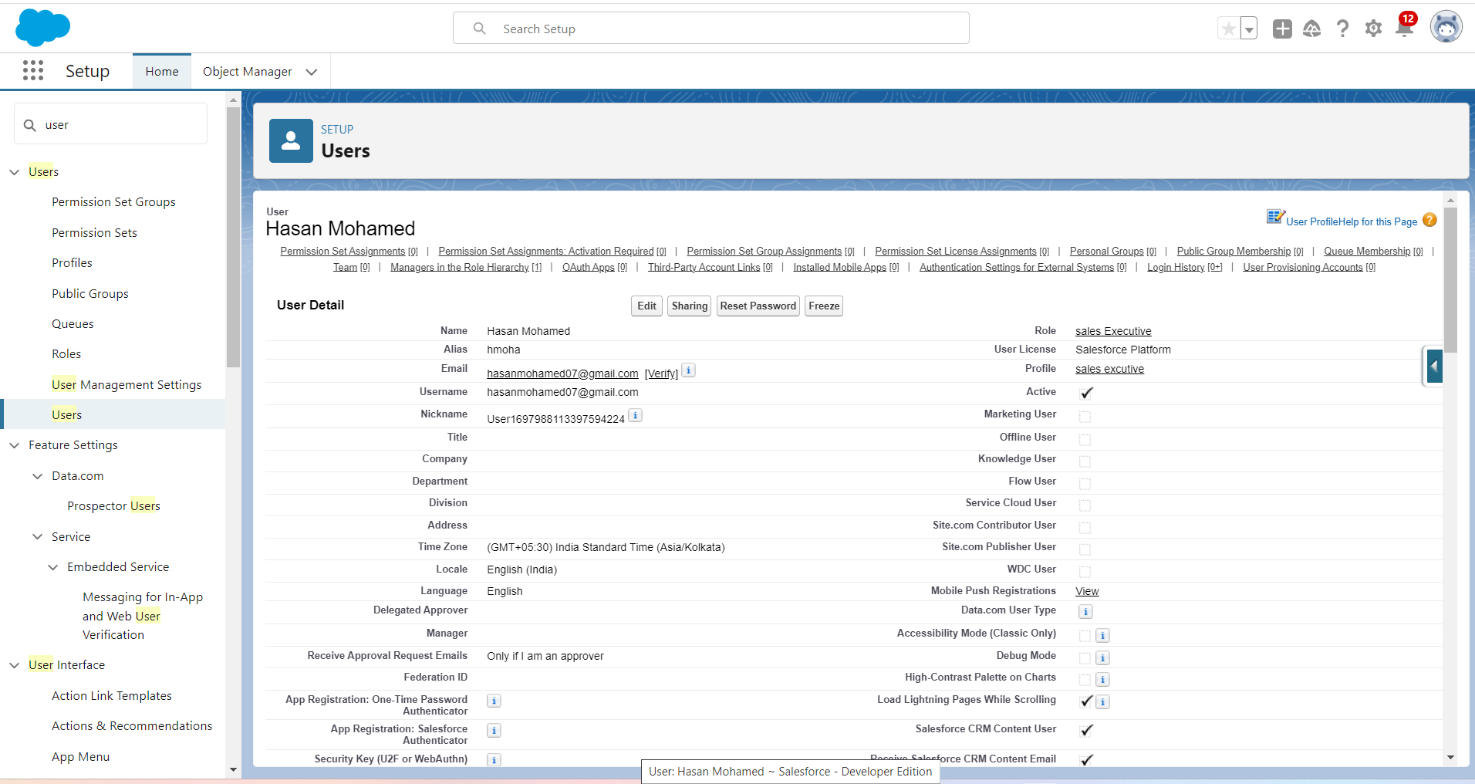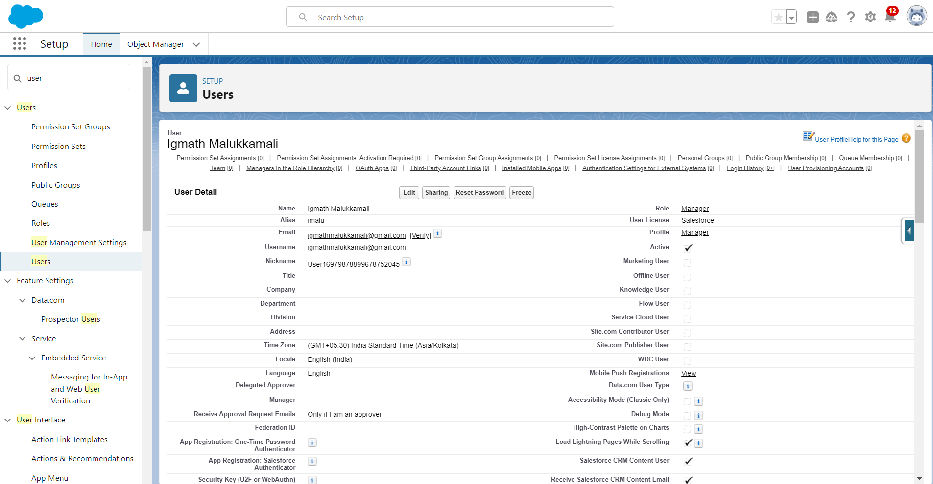

Step 9 : Create the Report

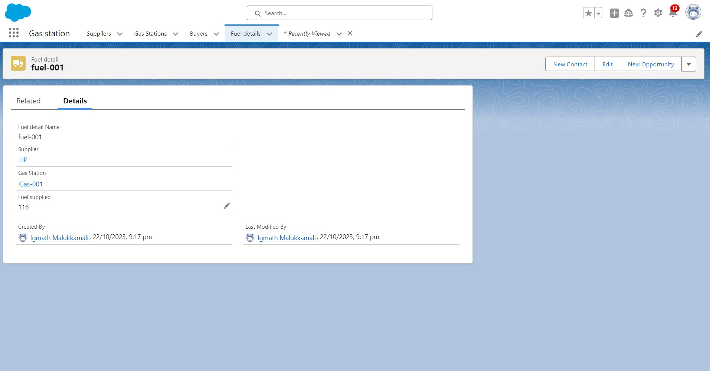

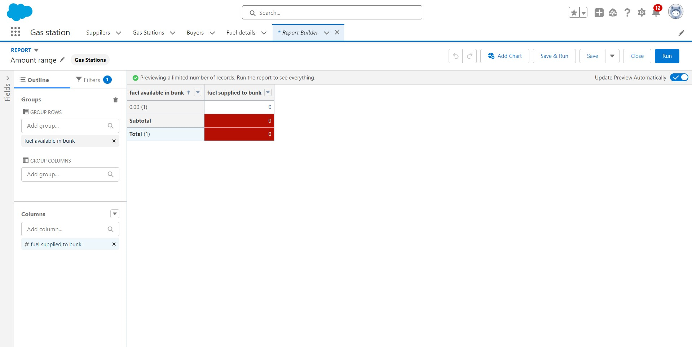

Step 10 : Create Records in Lightining App

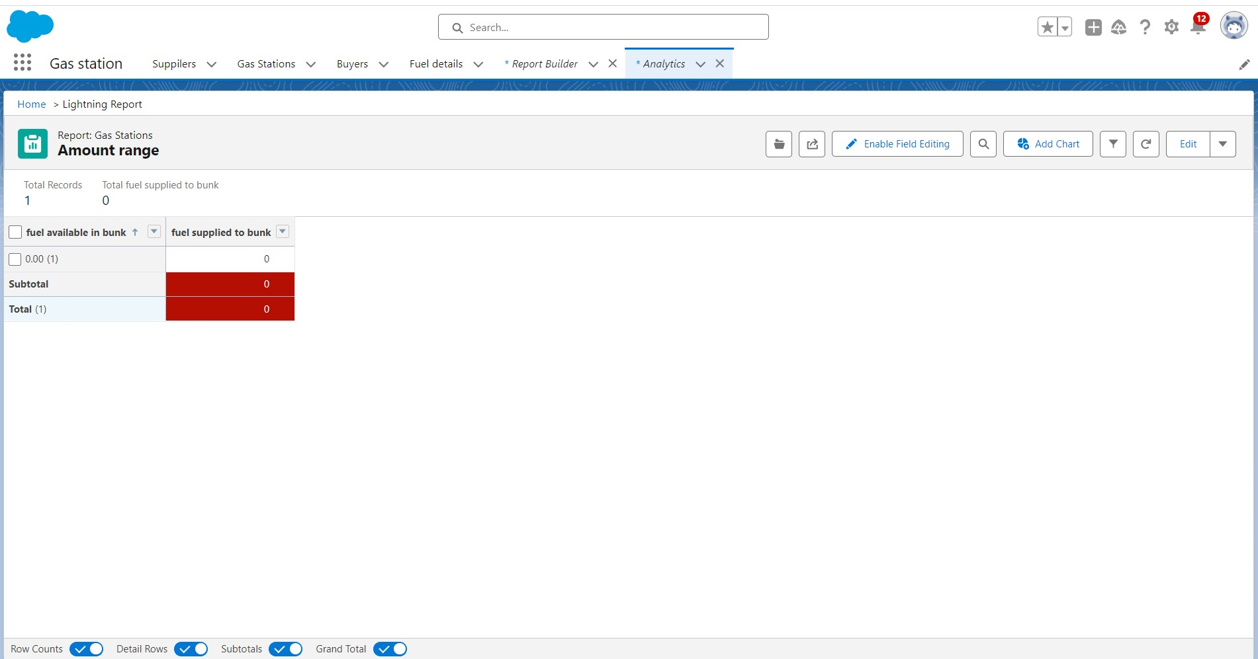

Step 11 : CREATE THE DASHBOARD

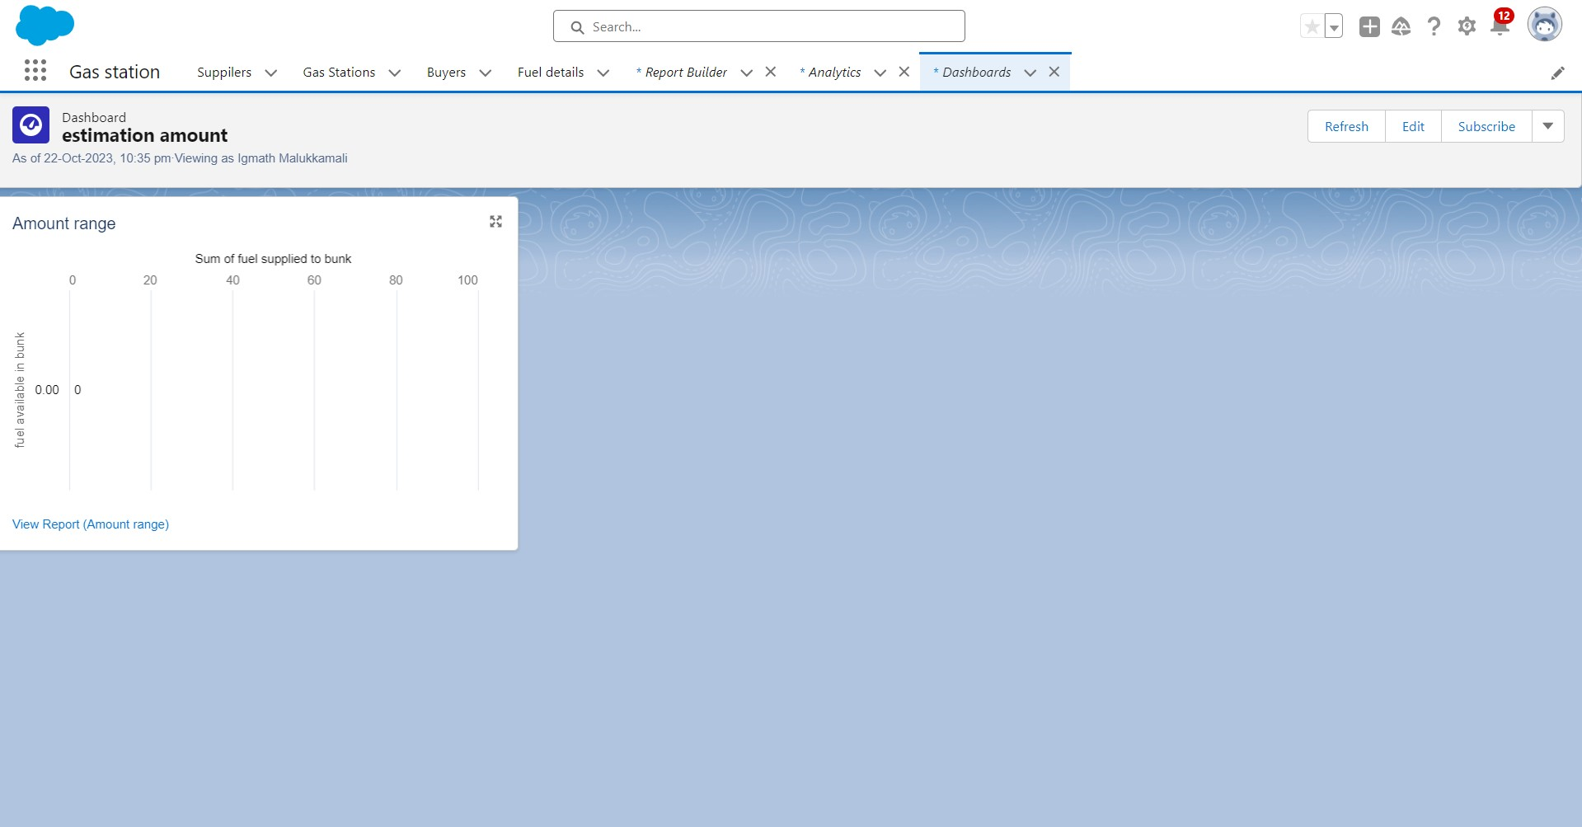

Step 12 : Create The Flow

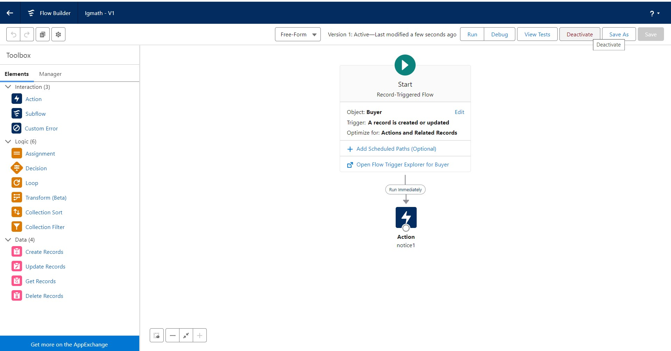

Step 13 : Create Apex Class, Apex Trigger

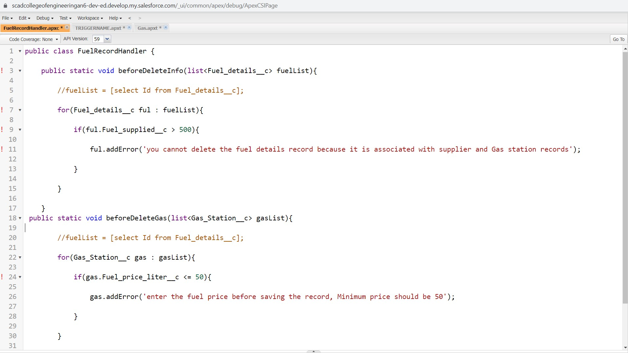

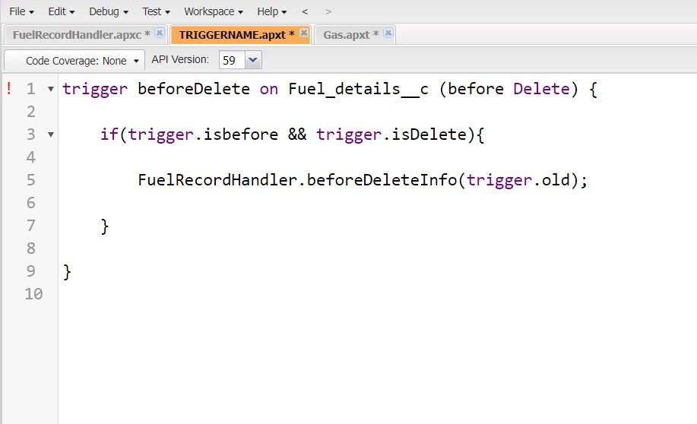

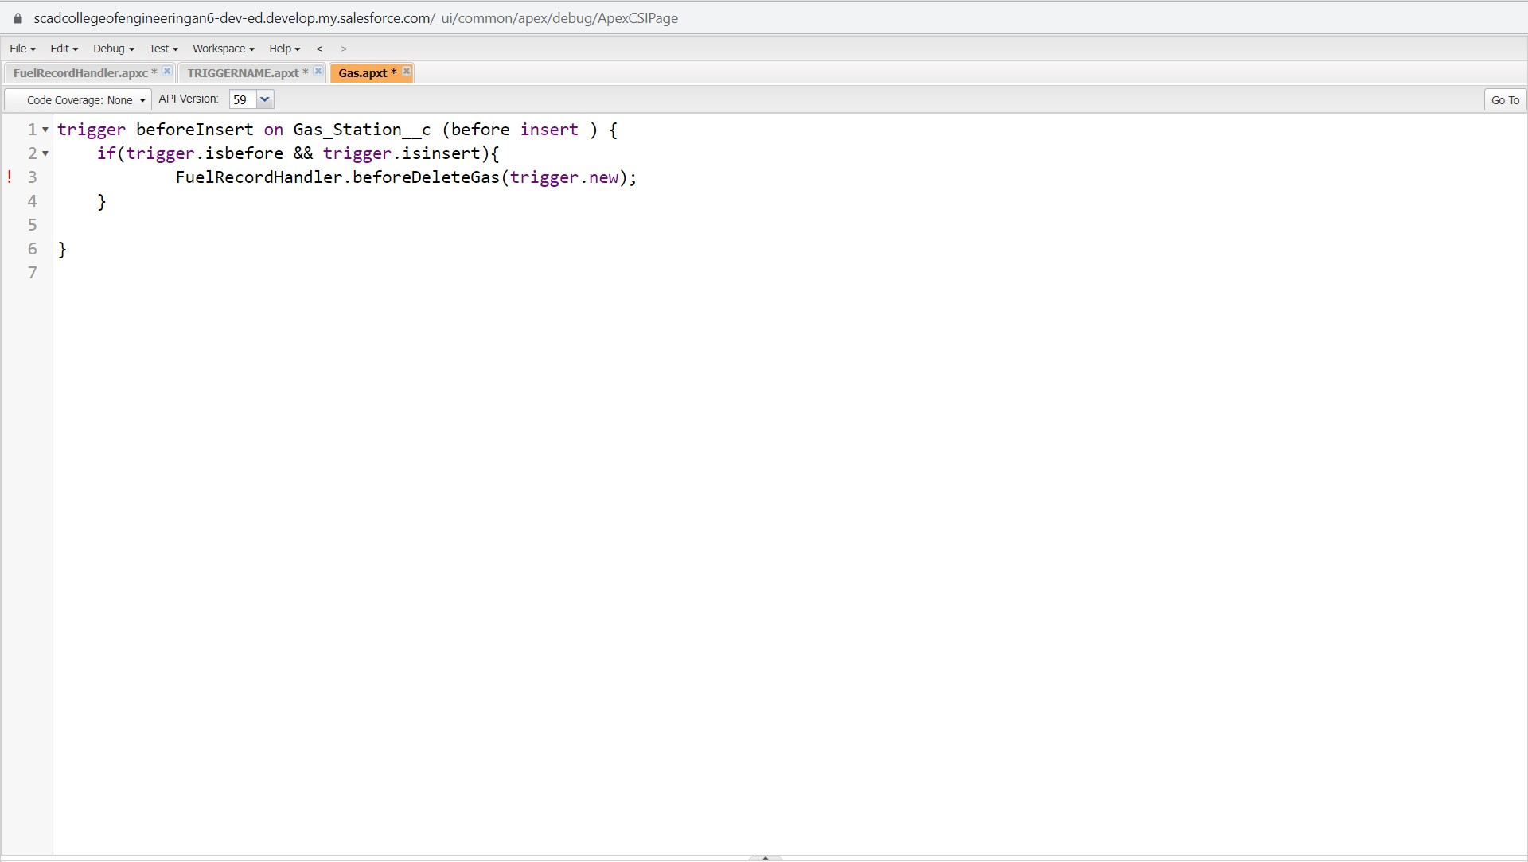

Thank you